**Filesystems on AWS**

**Extending Filesystem on AWS**

**AWS Filesystem**

**____________________________________________________________________________________**

**Version 1.01**

## INITIALS

For TFS AWS environments, we have 2 EBS volumes from which root filesystem “/” and “/opt/local” are created respectively.

Also to note, EC2 instances are created with CFT and to make any update like increasing the EBS volume can be completed by updating the stacks.

However, the root filesystem is created out of a template and can only be extended on the console.

Only the application volume can be updated through the CFT stack.

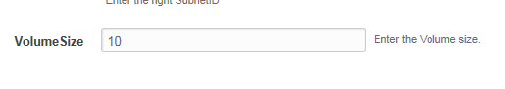

Please note: AWS support increasing the ESB volume and does not support reducing the EBS volume. Be careful of spaces added to volume.

## PROCESS

**Extend Root Filesystem**

Root Filesystem “/dev/sda1” can be extended from the AWS console.

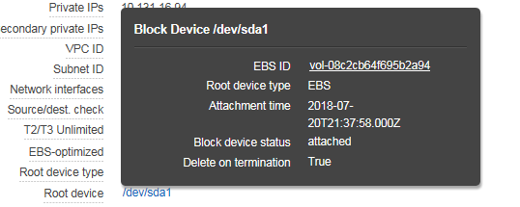

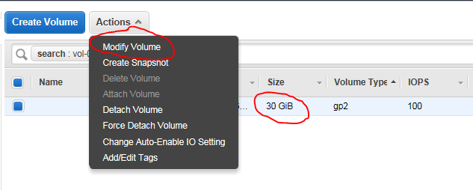

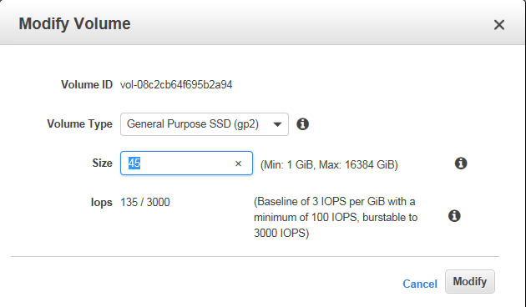

Once “modify” is applied, the root filesystem of the EC2 instance is updated immediately.

**Extend Application Filesystem**

As a recap, if the EC2 instance is built using CFT, extending the Volume where the FS lives should be done by updating the stack using the CFT.

Updating the volume does not extend the app FS “/opt/local”, there is a need for manual effort to extend the FS.

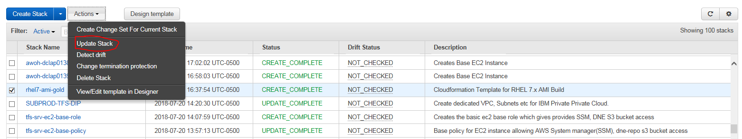

Select the “Stack Name” and click the action drop down to select “Update stack”

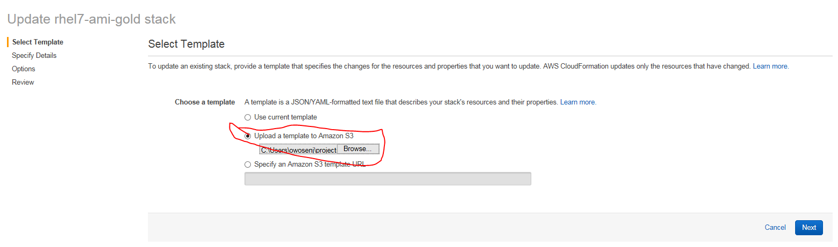

Upload the CFT and click Next to increase the volume;

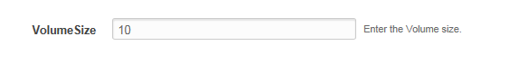

Click Next, Next and update.

This would increase the EBS volume for “/dev/sdb”

Please Note: /opt/local FS is created from a partitioned disk “/dev/sdb1”

**Manual Process to extend the FS**

Create a second partitioned from the added volume

echo -e "n\np\n2\n\n\nw" | fdisk /dev/sdb

pvcreate /dev/sdb2

vgextend app_vg /dev/sdb2 🡺 this would increase the volume group from where logical vol and FS can be extend online.

lvextend –L +<vol> -r <filesystem path>